AI Learning Assistant (Cognify)

Introduction:
In today’s digital learning environment, students and professionals are overwhelmed with large volumes of unstructured information such as PDFs, research papers, and lecture notes. Extracting key insights, understanding complex concepts, and retaining important information from these documents is often time-consuming and inefficient.
Traditional learning methods like manual reading and note-taking lack personalization and interactivity. Existing tools also fail to provide intelligent features such as automated summarization, contextual question answering, concept explanation, and adaptive learning techniques like quizzes and flashcards.
As a result, learners face challenges in:
- Identifying key information quickly
- Understanding complex topics without assistance
- Revising efficiently
- Tracking learning progress
- Interacting dynamically with study material
Moreover, current solutions are fragmented, requiring users to switch between multiple platforms for reading, summarizing, and practicing.
To address these issues, there is a need for a unified, AI-powered platform that can convert unstructured content into structured knowledge, provide real-time assistance, enable interactive learning, and track user progress.
Cognify aims to solve these challenges by integrating document processing, AI-driven insights, and interactive learning tools into a single seamless system, improving comprehension, retention, and overall learning efficiency.

Objectives :
The primary objective of Cognify – AI Learning Assistant is to develop an intelligent and scalable platform that improves how users learn from unstructured document-based content such as PDFs. The system focuses on transforming raw data into structured, meaningful insights, making it easier for users to extract key information and understand complex topics efficiently.
A major goal of the project is to leverage Artificial Intelligence through the integration of the Google Gemini API to automate essential learning tasks. These include generating summaries, explaining difficult concepts, creating quizzes for self-assessment, and producing flashcards for quick revision. By automating these processes, the platform reduces manual effort and enhances overall learning efficiency.
Another important objective is to provide an interactive learning experience through a chatbot interface. This allows users to ask context-based questions related to their documents and receive accurate, AI-generated responses, promoting active learning and better understanding.
The system also aims to build a robust backend using the MERN stack, where MongoDB is used to store and manage user data, documents, quizzes, flashcards, and chat history. Well-designed APIs ensure smooth data flow, consistency, and scalability.
In addition, the project focuses on delivering a user-friendly frontend with a personalized dashboard, enabling users to manage documents, track progress, and access study materials easily.
Overall, Cognify aims to combine document processing, AI-driven insights, and interactive tools into a single unified platform, improving learning effectiveness, engagement, and knowledge retention.

Scope of the Project :
The scope of Cognify – AI Learning Assistant includes the design and development of a full-stack web application that uses Artificial Intelligence to enhance document-based learning. The system is designed to help students and professionals interact with and understand unstructured content, particularly PDF documents, in a more efficient and engaging way.
The project covers the implementation of a document management system that allows users to upload, access, and manage their documents securely. Users can perform essential operations such as adding, viewing, and deleting documents, ensuring flexibility in handling their learning resources.
A key part of the scope is the integration of AI-powered features using the Google Gemini API. The system enables automatic generation of summaries, concept explanations, quizzes, and flashcards. These features convert static document content into interactive learning material, improving comprehension and retention.
The scope also includes an AI-based chatbot that allows users to ask questions related to their uploaded documents. The chatbot provides context-aware responses and maintains chat history for continuity, enabling a more interactive learning experience.
From a backend perspective, the project involves building scalable data models using MongoDB to store users, documents, quizzes, flashcards, and chat data. RESTful APIs developed using Node.js and Express.js handle communication, data processing, and AI integration.
On the frontend, a responsive interface is developed using React.js, providing a personalized dashboard where users can manage documents, track activity, and access generated content easily.
However, the scope is limited to text-based document processing and AI-generated outputs. It does not include multimedia processing, real-time collaboration, or offline functionality. The accuracy of results depends on the quality of input documents and AI capabilities.
Overall, the project focuses on delivering a unified platform that combines document management, AI-driven analysis, and interactive learning tools, with scope for future enhancements.

System Overview :
Cognify – AI Learning Assistant is a full-stack, AI-powered web application designed to transform traditional document-based learning into an interactive, intelligent, and efficient experience. The system is built using the MERN stack (MongoDB, Express.js, React.js, Node.js) and integrates advanced AI capabilities through the Google Gemini API to process and analyze document content.
At a high level, the system allows users to upload PDF documents, which are then processed and analyzed to extract meaningful textual content. This extracted content serves as the foundation for all AI-driven functionalities within the platform. Once a document is uploaded, users can interact with it in multiple ways, such as generating summaries, explaining specific concepts, creating quizzes, and generating flashcards for revision.
The architecture of the system follows a client-server model. The frontend, built with React.js and styled using Tailwind CSS, provides a responsive and user-friendly interface where users can manage documents, access AI features, and interact with the system. The backend, developed using Node.js and Express.js, handles business logic, API requests, authentication, and communication with the database and AI services.
MongoDB is used as the primary database to store and manage all application data, including user profiles, uploaded documents, extracted text, chat history, quizzes, and flashcards. The database is designed to efficiently handle structured and semi-structured data, enabling fast retrieval and scalability as the number of users and documents grows.
A key component of the system is the AI integration layer, where the Google Gemini API is used to perform various intelligent operations. These include generating concise summaries, providing detailed explanations of concepts, creating assessment quizzes, and enabling a chatbot that can answer user queries based on document content. The chatbot uses contextual information from the document to deliver accurate and relevant responses, enhancing the overall learning experience.
The system also includes a personalized dashboard that allows users to view their uploaded documents, track their activity, and access previously generated learning materials. This ensures that users can easily manage and revisit their study resources.
In terms of workflow, the system begins with user authentication, followed by document upload and processing. Once the document is available, users can invoke different AI features through API calls. The results are then displayed in the frontend in a structured and readable format, often supporting markdown rendering for better presentation.
Overall, Cognify is designed as a modular and scalable system, where each component—frontend, backend, database, and AI services—works cohesively to deliver a seamless and intelligent learning platform. The system emphasizes usability, performance, and extensibility, making it adaptable for future enhancements such as advanced analytics, improved AI models, and collaborative learning features.

System Requirements :
The requirements of Cognify – AI Learning Assistant define the essential functionalities and performance expectations of the system. These requirements are broadly classified into Functional Requirements and Non-Functional Requirements, ensuring that the system not only performs the intended tasks but also meets quality standards such as performance, scalability, and usability.

1. Functional Requirements
Functional requirements describe the core features and operations that the system must perform.

1.1 User Authentication and Management
- The system shall allow users to register and log in securely.
- The system shall support authentication mechanisms to protect user data.
- The system shall allow users to manage their profiles.
- The system shall maintain session management for logged-in users.

1.2 Document Management
- The system shall allow users to upload PDF documents.
- The system shall extract and process text from uploaded documents.
- The system shall store document metadata and extracted content in the database.
- The system shall allow users to view documents within the platform.
- The system shall support CRUD operations (Create, Read, Update, Delete) for documents.
- The system shall associate documents with specific users.

1.3 AI-Based Summary Generation
- The system shall generate concise summaries of uploaded documents using AI.
- The system shall display summaries in a structured and readable format.
- The system shall allow users to regenerate summaries if needed.

1.4 Concept Explanation
- The system shall allow users to input a specific concept or topic.
- The system shall generate detailed explanations based on document context.
- The system shall provide clear and understandable explanations.
- The system shall display explanations in a user-friendly format.

1.5 Quiz Generation
- The system shall generate multiple-choice quizzes based on document content.
- The system shall provide multiple options and indicate correct answers.
- The system shall store quiz data for future access.
- The system shall allow users to attempt quizzes and track results.

1.6 Flashcard Generation
- The system shall generate flashcards containing questions and answers.
- The system shall categorize flashcards based on difficulty levels.
- The system shall allow users to review and revisit flashcards.

1.7 Chatbot Functionality
- The system shall provide a chatbot interface for user interaction.
- The chatbot shall answer questions based on document content.
- The system shall maintain chat history for each user and document.
- The system shall retrieve relevant document content to generate accurate responses.

1.8 Dashboard and User Activity
- The system shall provide a dashboard displaying user activity.
- The system shall allow users to view uploaded documents, quizzes, and flashcards.
- The system shall track and display user progress and interactions.

1.9 API and Backend Services
- The system shall provide RESTful APIs for all major functionalities.
- The system shall handle communication between frontend and backend efficiently.
- The system shall integrate with external AI services (Google Gemini API).

2. Non-Functional Requirements
Non-functional requirements define the quality attributes and constraints of the system.

2.1 Performance Requirements
- The system shall process document uploads and AI responses within acceptable time limits.
- The system shall handle multiple user requests efficiently.
- The system shall minimize latency in chatbot and AI responses.

2.2 Scalability
- The system shall be designed to handle an increasing number of users and documents.
- The backend shall support horizontal scaling.
- The database shall efficiently manage large volumes of data.

2.3 Reliability
- The system shall ensure consistent performance under normal usage conditions.
- The system shall handle errors gracefully and provide meaningful feedback.
- The system shall ensure data integrity and prevent data loss.

2.4 Security
- The system shall ensure secure authentication and authorization.
- The system shall protect user data and sensitive information.
- The system shall prevent unauthorized access to documents and user data.
- The system shall follow secure API practices.

2.5 Usability
- The system shall provide a user-friendly and intuitive interface.
- The system shall ensure easy navigation across features.
- The system shall display information in a clear and organized manner.

2.6 Maintainability
- The system shall follow modular coding practices.
- The codebase shall be easy to update and maintain.
- The system shall support debugging and testing processes.

2.7 Compatibility
- The system shall be accessible across modern web browsers.
- The system shall support responsive design for different screen sizes.

2.8 Availability
- The system shall ensure high availability for users.
- The system shall minimize downtime during operation.

2.9 Extensibility
- The system shall be designed to support future enhancements.
- The system shall allow integration of additional AI features and services.

Design and Architecture

High-Level Architecture Overview
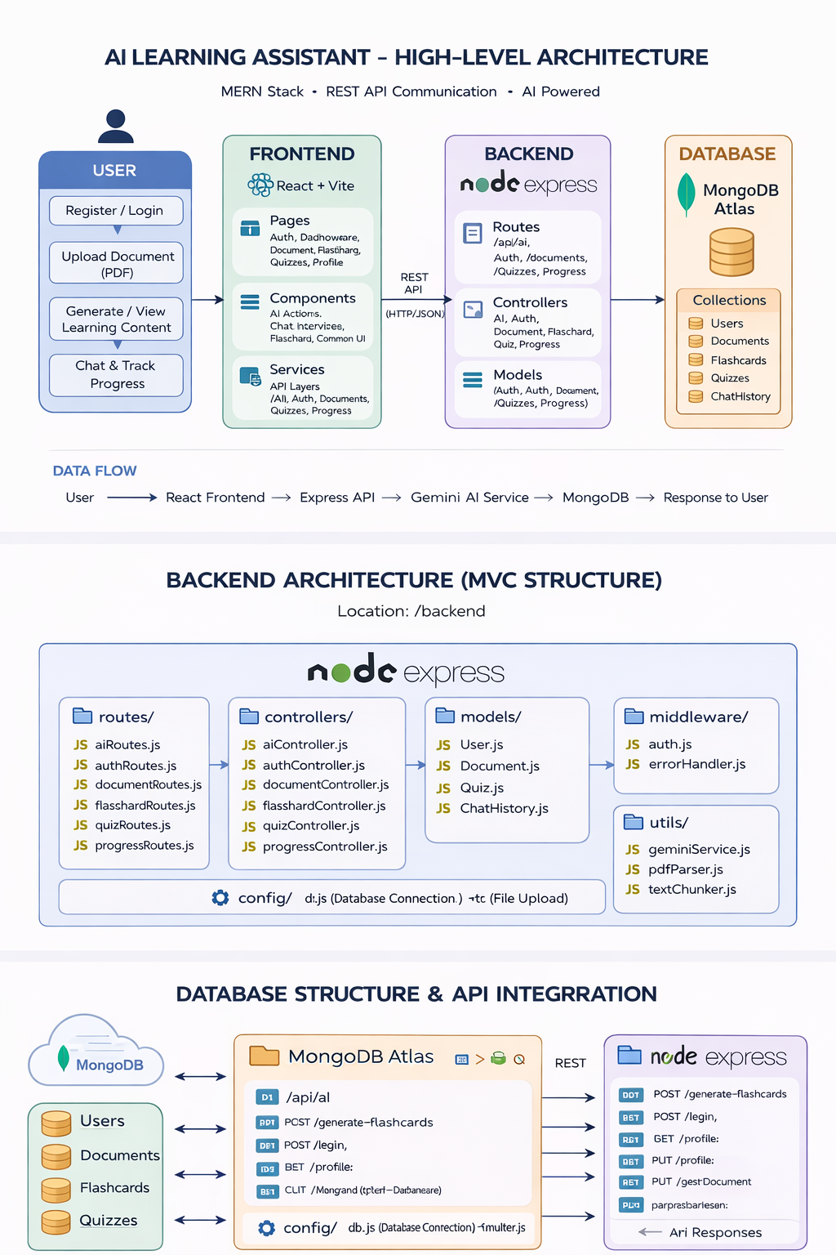

1.1 Architecture Type:
- Full Stack MERN Application
- AI-Integrated Backend (Gemini API)
- REST API based communication

1.2 High-Level Workflow:
- User interacts with React Frontend
- Requests go to Express Backend APIs
- Backend:
  - Authenticates user (JWT)
  - Processes documents (PDF parsing, chunking)
  - Calls Gemini AI Service
- Data stored in MongoDB
- Response sent back to frontend

2. System Components

2.1 Frontend (React + Vite)
Location: /frontend/src

2.1.1 Responsibilities:
- User Interface rendering
- API calls
- State management
- Route Protection

2.1.2 Key Modules:
- Pages
  - Auth → Login/Register
  - Dashboard
  - Documents
  - Flashcards
  - Quizzes
  - Profile
- Components
  - AI → AI Actions
  - Chat → ChatInterface
  - Flashcards → Flashcard UI
  - Common → Buttons, Spinner, Tabs
- Services
  - API abstraction layer:
    - AIService.js
    - AuthService.js
    - documentService.js
    - quizService.js

2.2 Backend (Node.js + Express)
Location: /backend

2.2.1 Architecture Pattern:
MVC (Model-View-Controller)

2.2.2 Backend Layers:
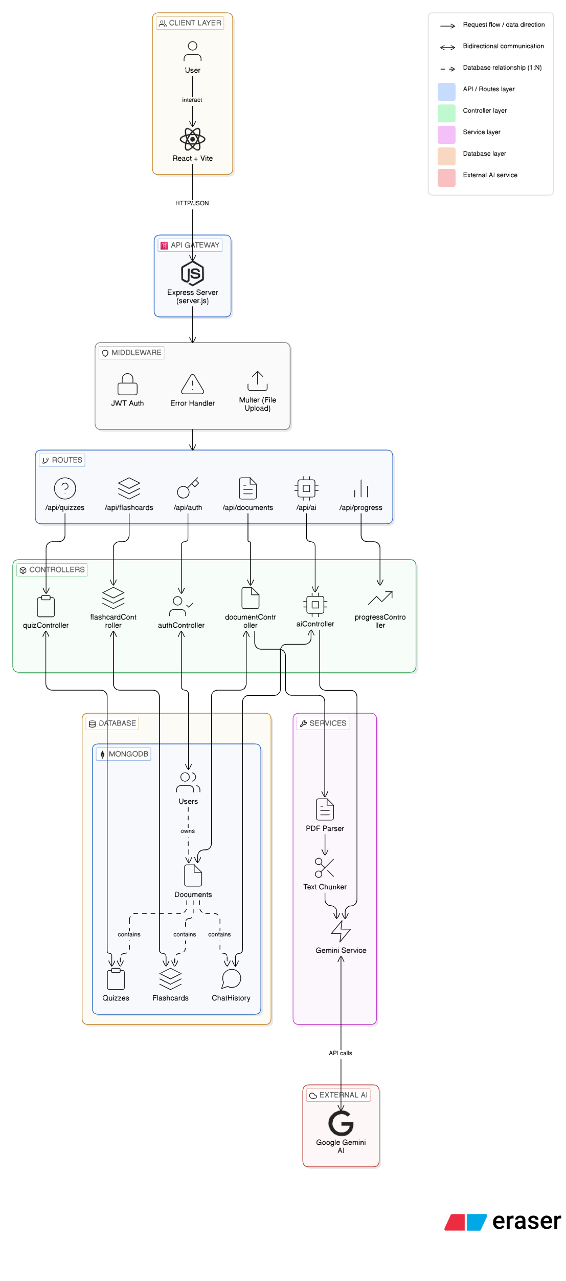

1. Routes Layer
Handles API endpoints
Route File | Purpose
authRoutes.js | Authentication
aiRoutes.js | AI features
documentRoutes.js | File upload & management
flashcardRoutes.js | Flashcards
quizRoutes.js | Quiz
progressRoutes.js | Dashboard

2. Controller Layer
Business logic execution
Controller File | Purpose
authController.js | Authentication
aiController.js | AI features
documentController.js | File upload & management
flashcardController.js | Flashcards
quizController.js | Quiz
progressController.js | Dashboard

3. Model Layer (MongoDB + Mongoose)
Model | Purpose
User | User data
Document | Uploaded files
Flashcard | AI-generated flashcards
Quiz | AI-generated quizzes
ChatHistory | AI conversations

4. Middleware
- auth.js → JWT Authentication
- errorHandler.js → Error handling

5. Utilities
- geminiService.js → AI integration
- pdfParser.js → Extract text
- textChunker.js → Break content

6. Config
- db.js → Database connection
- multer.js → File uploads

3. AI Processing Pipeline
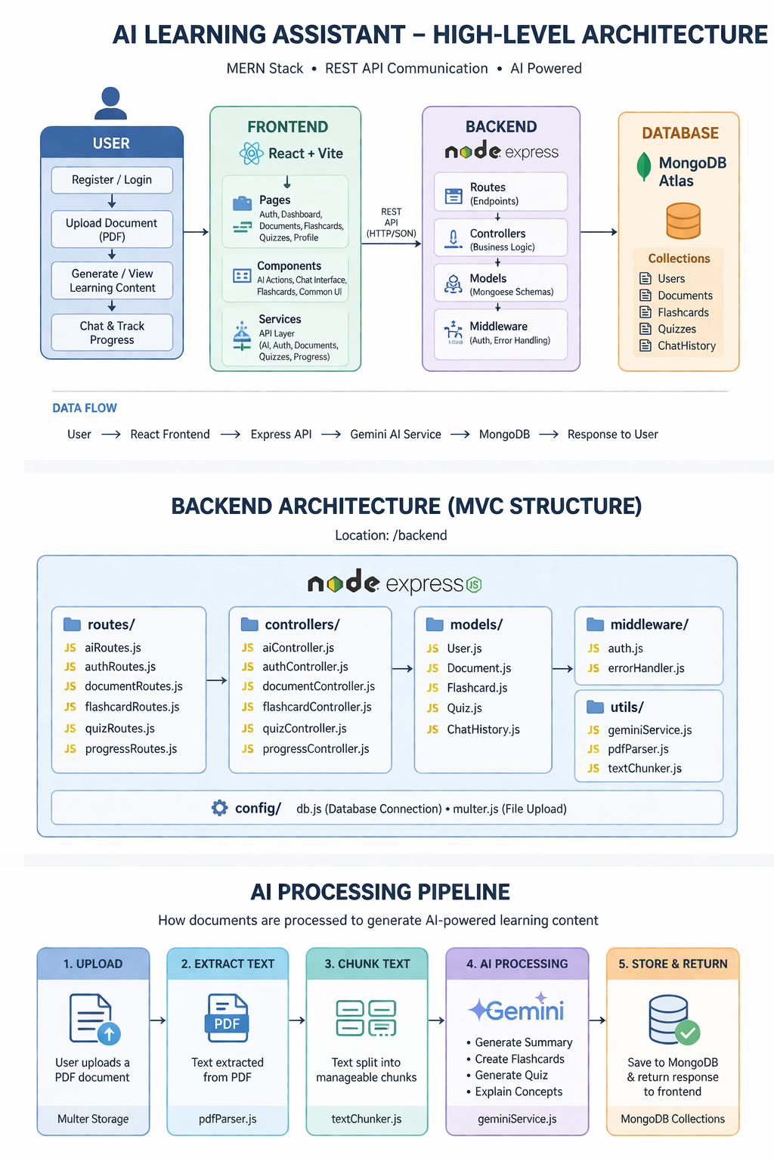

3.1 Flow:
- Upload PDF
- Extract text (pdfParser)
- Split into chunks (textChunker)
- Send to Gemini AI
- Generate:
  - Summary
  - Flashcards
  - Quiz
  - Explanations
- Store results in DB

4. Authentication Flow
- JWT-based authentication
- Protected routes using middleware

4.1 Flow:
- User logs in
- Server returns JWT
- Token stored (frontend)
- Sent in headers for protected routes
- protect middleware verifies token

5. API Design

5.1 AI Routes (/api/ai)
Method | Endpoint | Function
POST | /generate-flashcards | Generate flashcards
POST | /generate-quiz | Generate quiz
POST | /generate-summary | Generate summary
POST | /chat | Chat with AI
POST | /explain-concept | Explain topic
GET | /chat-history/:documentId | Fetch chat history

5.2 Auth Routes (/api/auth)
Method | Endpoint
POST | /register
POST | /login
GET | /profile
PUT | /profile
PUT | /change-password

5.3 Document Routes (/api/documents)
Method | Endpoint
POST | /upload
GET | /
GET | /:id
DELETE | /:id

5.4 Flashcard Routes (/api/flashcards)
Method | Endpoint
GET | /
GET | /:documentId
POST | /:cardId/review
PUT | /:cardId/star
DELETE | /:id

5.5 Quiz Routes (/api/quizzes)
Method | Endpoint
GET | /quiz/:id
POST | /:id/submit
GET | /:id/results
DELETE | /:id
GET | /:documentId

5.6 Progress Routes (/progress)
Method | Endpoint
GET | /dashboard

6. Database Design

6.1 Collections:
- Users
- Documents
- Flashcards
- Quizzes
- ChatHistory

6.2 Relationships:
- User → Documents (1:N)
- Document → Flashcards (1:N)
- Document → Quizzes (1:N)
- Document → ChatHistory (1:N)

Future Scope :
Cognify – AI Learning Assistant has been designed as a scalable and extensible platform, leaving significant room for future enhancements. As technology evolves and user needs grow, the system can be further improved to provide a more intelligent, personalized, and collaborative learning experience. The following points outline the potential future scope, improvements, and additional requirements for the system.

1. Advanced AI Features
- Improve accuracy using advanced AI models
- Support long-document understanding
- Enable adaptive learning based on user performance
- Add multi-language and voice interaction support

2. Knowledge Structuring
- Introduce knowledge graphs for concept relationships
- Enable automatic tagging and categorization
- Implement semantic search for better retrieval

3. Enhanced Interaction
- Improve chatbot with contextual memory
- Support cross-document queries
- Provide real-time suggestions

4. Collaboration Features
- Enable sharing of documents and content
- Support collaborative learning and discussions
- Add comments and annotations

5. Analytics & Tracking
- Provide detailed performance dashboards
- Track quiz scores, time spent, and progress trends
- Introduce goal-setting features

6. Scalability Improvements
- Move to microservices architecture
- Optimize performance with caching
- Enhance database for large-scale usage
- Deploy with cloud auto-scaling

7. Mobile Support
- Develop Android and iOS apps
- Enable offline access
- Sync data across devices

8. External Integrations
- Integrate with LMS platforms (e.g., Moodle)
- Support cloud storage (Google Drive, Dropbox)
- Provide APIs for third-party use

9. Security Enhancements
- Implement encryption and role-based access
- Add OAuth and multi-factor authentication
- Ensure data protection compliance

10. Content Expansion
- Support additional formats like Word, web content, audio, and video

Conclusion :
Cognify – AI Learning Assistant successfully demonstrates the integration of modern web technologies and artificial intelligence to address the challenges associated with traditional document-based learning. The system provides a unified platform that transforms unstructured PDF content into structured, interactive, and meaningful learning resources, thereby improving both efficiency and user engagement.
By leveraging the MERN stack for full-stack development and integrating the Google Gemini API for AI-driven functionalities, the platform enables users to generate summaries, understand complex concepts, create quizzes, and review content through flashcards. The inclusion of a chatbot further enhances the learning experience by allowing users to interact dynamically with document content and receive contextual answers in real time.
The project also emphasizes scalability, modular design, and efficient data management by implementing structured backend services and database models to handle users, documents, and generated learning data. The user-friendly interface and personalized dashboard contribute to a seamless and organized learning workflow.
Overall, Cognify bridges the gap between passive content consumption and active learning by combining automation, interactivity, and intelligent data processing. It not only reduces the time and effort required to study large volumes of information but also enhances comprehension and retention. With its extensible architecture and strong foundation, the system holds significant potential for future enhancements, making it a valuable solution in the domain of AI-powered education and knowledge management.

